

**Project Vision:**

For my college project, I've chosen to design a cloud architecture and pipeline strategy for ShopCom, an innovative e-commerce company revolutionizing online shopping. ShopCom prioritizes innovation and convenience, offering a seamless platform for customers to explore the latest trends and curate their unique style statements. With a focus on customer satisfaction, ShopCom aims to redefine the digital shopping experience through personalized order management and a dynamic, immersive environment. Stay tuned as I delve into crafting a robust cloud architecture and efficient pipeline strategy to support ShopCom's growth and enhance its online presence.

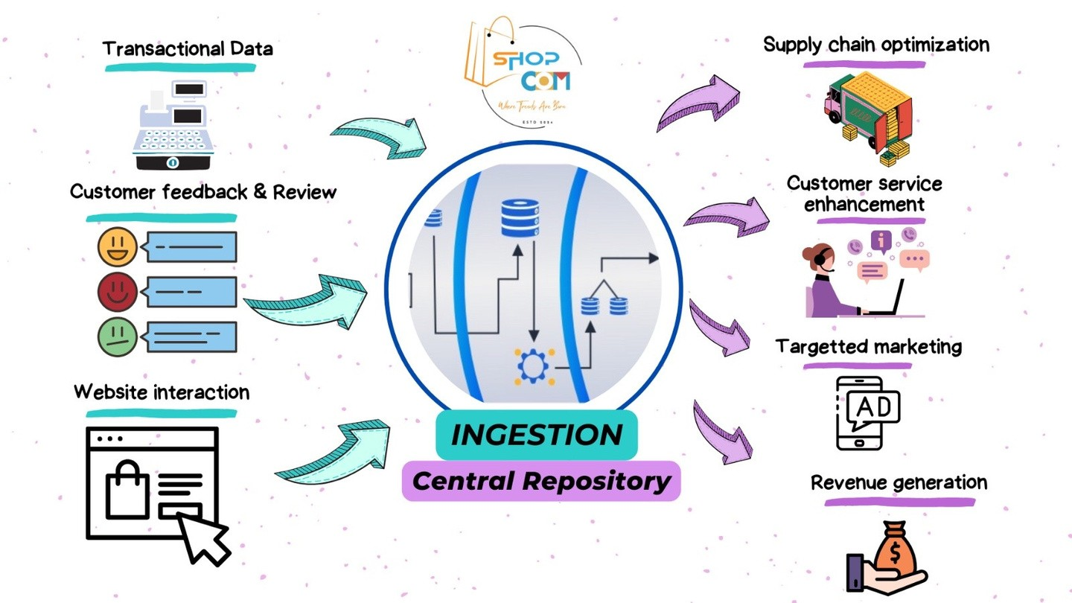

**Cloud Architecture:**

In the cloud architecture I'm crafting using Microsoft Azure, I integrate various data sources critical to ShopCom's operations. These sources include transactional data, currency conversion, website interaction, and geo-location information.

Transactional data is ingested into the Bronze Layer of the Lakehouse through Event Hubs in its raw form, while data from other sources is ingested into the Bronze Layer via Azure Data Storage.

Once in the Bronze Layer, raw data undergoes transformation using Azure Databricks before being stored in the Silver Layer (also known as the Curation Layer) of the Lakehouse. Here, the transformed data is refined and prepared for further analysis.

Subsequently, this refined data is aggregated and stored in the Gold Layer (Aggregation Layer) of the Lakehouse. The Gold Layer serves as a repository for high-quality, aggregated data ready for advanced analytics and machine learning applications.

Both the Silver and Gold Layers play crucial roles in ShopCom's operations. While data from the Silver Layer contributes to AI and machine learning initiatives, the Gold Layer data is leveraged for optimizing supply chain processes, streamlining revenue, and facilitating data visualization for informed decision-making.

This architecture ensures that ShopCom harnesses the power of its data effectively, enabling insights that drive business growth and enhance customer experience. 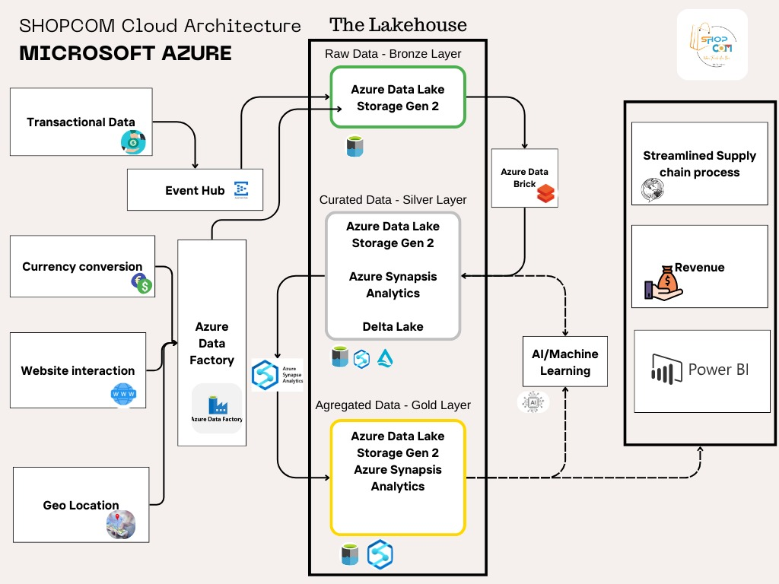

**Pipeline Strategy:**

1. **Data Ingestion:**

* Utilize Azure Event Hubs for real-time ingestion of transactional data.
* Configure Azure Data Factory pipelines to ingest data from various sources like currency conversion, website interaction, and geo-location into the Bronze Layer via Azure Data Storage.

1. **Data Transformation:**

* Implement Azure Databricks jobs for transforming raw data in the Bronze Layer into refined data suitable for analysis.
* Manage and trigger Databricks jobs using Azure Data Factory.

1. **Data Storage:**

* Store transformed data in the Silver Layer (Curation Layer) of the Lakehouse using Azure Data Lake Storage Gen2.
* Optimize storage efficiency through partitioning techniques.

1. **Data Aggregation:**

* Design Azure Databricks jobs to aggregate refined data from the Silver Layer into the Gold Layer (Aggregation Layer).
* Utilize appropriate aggregation techniques to extract valuable insights.

1. **Advanced Analytics and Machine Learning:**

* Leverage Azure Machine Learning to build and deploy models using data from the Silver Layer and Gold Layer
* Utilize Azure Databricks for exploratory data analysis, model training, and evaluation.

1. **Business Insights and Decision Making:**

* Develop Power BI dashboards and reports for visualizing insights derived from the Gold Layer data.
* Integrate Power BI with Azure services for real-time data visualization and monitoring.

1. **Monitoring and Optimization:**

* Implement Azure Monitor and Azure Log Analytics for monitoring pipeline performance, data quality, and resource utilization.
* Utilize Azure Advisor for recommendations on optimizing pipeline efficiency and cost-effectiveness.

1. **Security and Compliance:**

* Ensure secure storage and management of sensitive credentials and keys using Azure Key Vault.
* Configure role-based access control (RBAC) to govern data access and maintain compliance standards.

Implementing these strategies will empower ShopCom to efficiently process, analyze, and leverage its data to drive informed decision-making and enhance the overall customer experience.

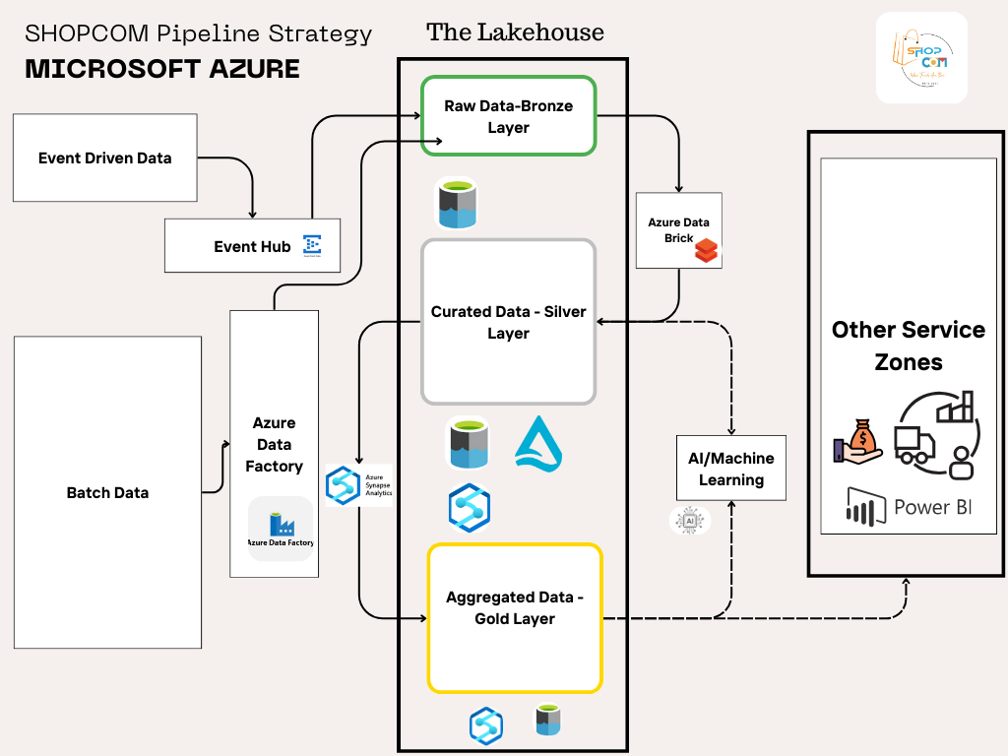

**Conclusion:**

In conclusion, this project aims to empower ShopCom, the innovative e-commerce platform, with a cutting-edge cloud architecture and robust pipeline strategy in Microsoft Azure. By seamlessly integrating critical data sources and leveraging advanced technologies like Azure Event Hubs, Data Factory, Databricks, and Azure Machine Learning, ShopCom can unlock the full potential of its data.

Through efficient data ingestion, transformation, storage, and aggregation processes, ShopCom can derive valuable insights that fuel advanced analytics, machine learning, and business intelligence initiatives. With Power BI dashboards enabling real-time visualization and monitoring, ShopCom can make data-driven decisions that optimize operations, streamline revenue, and enhance the overall customer experience.

Moreover, by prioritizing security, compliance, monitoring, and optimization, ShopCom ensures the integrity, reliability, and efficiency of its data pipeline. Ultimately, this project sets the stage for ShopCom to continue revolutionizing the e-commerce landscape, delivering unparalleled innovation and convenience to its customers while driving sustainable business growth.